

**Centro Bilingüe Bellas Luces**

**Teacher Arantxa Tejeira**

**Prekinder A**

**Worksheets from March 13 to 20.**

**The numbers**

From 1 to 5

Color by numbers. Count the numbers.

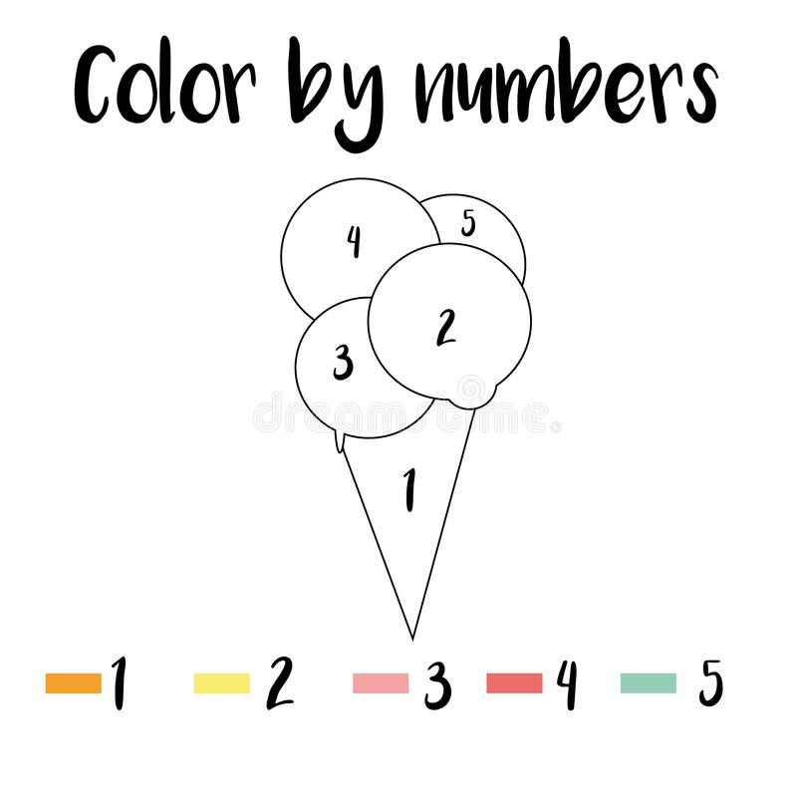

1 

2

3

4

5

**The greetings**

Say **Good Morning** when the sun is out. Say **Goodnight** when the moon is out.

Repeat the greetings and color the picture. The students need to learn the different between the greetings.

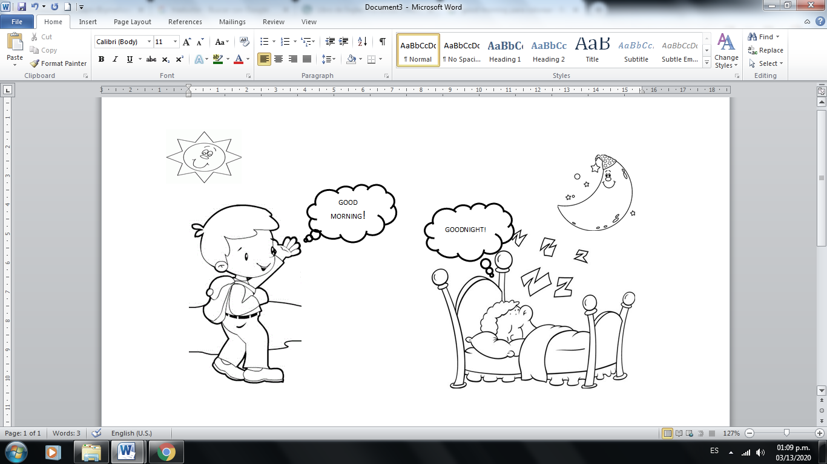

**The greetings**

Repeat the greetings. Good morning/ Goodnight. Color.



**GOOD MORNING!**



**GOODNIGHT!**