**Ministerio de Educación**

**Dirección Regional de Educación Particular**

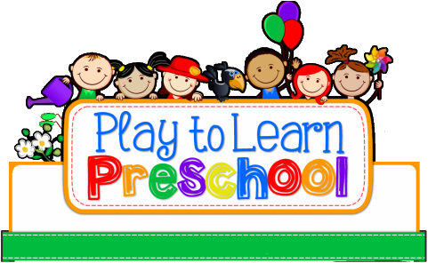

Centro Bilingüe Bellas Luces

Teacher Arantxa Tejeira

English Class

Prekinder A

Worksheets from March 30th to April 2nd .

**CAREFULLY READ THE DIRECTIONS.**

**Cada hoja de trabajo debe ser impresa y entregada en un folder e identificado con el nombre de cada estudiante. (En un folder por motivos de que el cuaderno quedo en el colegio) Entregarse al regresar a clases. Se evaluara de forma oral cada tema al regresar a clases.**

1. **Numbers 8, 9**

|  |  |
| --- | --- |
| **Day** | Tuesday 31st of March, 2020 |
| **Lesson objective** | * Count to 9 and recognize the numbers until 9. * Improve counting numbers. |
| **Key language** | 1,2,3,4,5,6,7,8,9  Name’s numbers |

**3.1 Worksheet to do:**

3.1 Count out loud the object around the numbers. Color the numbers and the objects around.

1. **Preposition In and On**

|  |  |
| --- | --- |
| **Day** | Thursday 2nd of April, 2020 |
| **Lesson objective** | * Understand and use the preposition in and on * Practice the prepositions |
| **Key language** | in,on |

**(Ejemplo: in:** adentro , **on:** sobre)

**4.1 Worksheet to do:**

* 1. Identify the propositions of each object.

**Example:** Preposition **IN**  Preposition **ON**

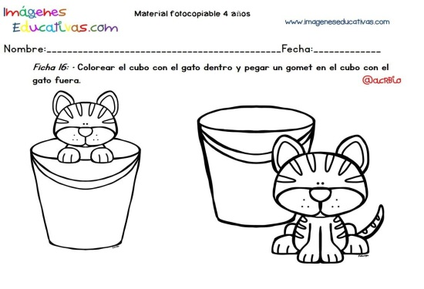 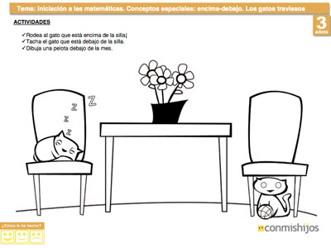  

Nota: **Porfavor, repasemos con los niños en casa los números en inglés. Dios los bendiga.**

**3.1 Worksheet**

**Numbers 8,9**

Count out loud the object around the numbers. Color the numbers and the objects around.

**Eight**

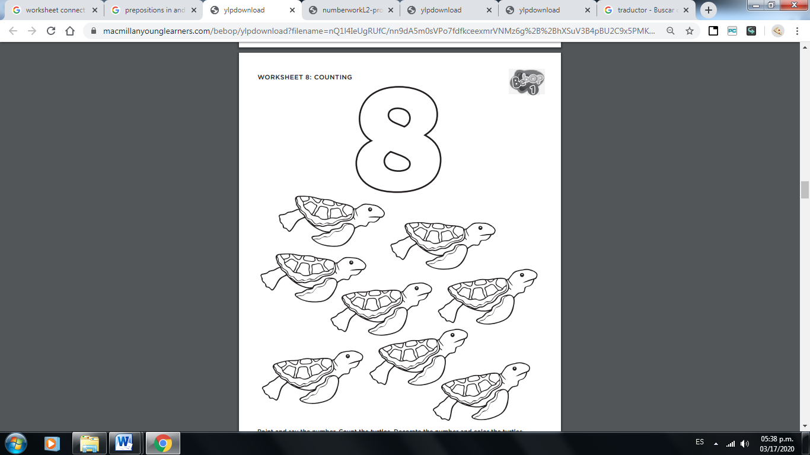

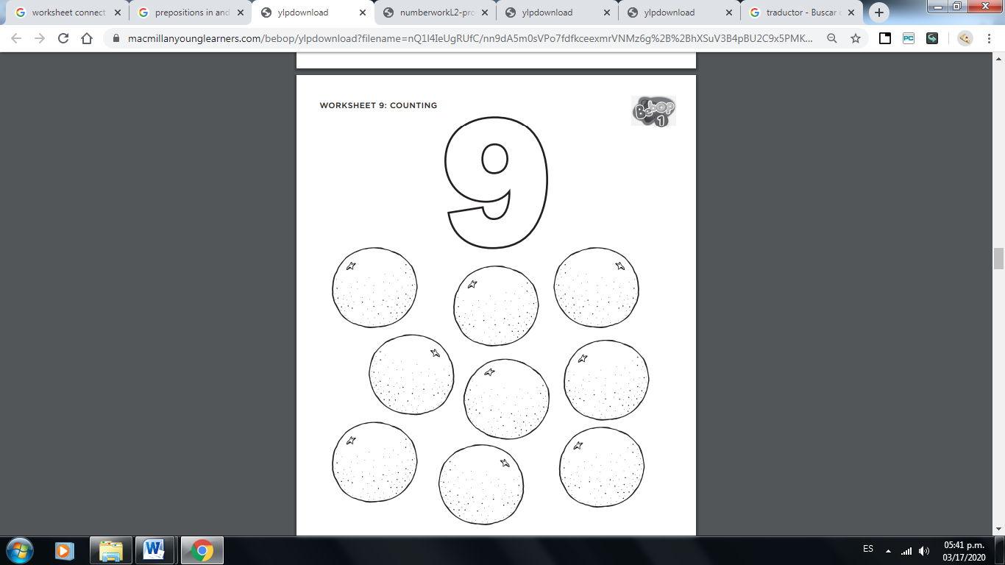

**Nine**

**4.1 Worksheet**

**Preposition IN and ON**

Circle with color **RED** the things IN, Circle with color **BLUE** the things ON.

