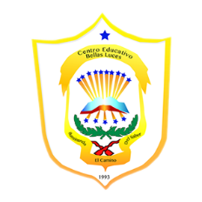República de Panamá

Ministerio de Educación

Educación Particular

Centro Educativo Bilingüe Bellas Luces

Date: **Monday April 13 to Friday 17.**  Teacher: Yinelli Núñez

**SUBJECT: GRAMMAR** LEVEL: 9 GRADE

***“AS FOR ME AND MY HOUSE WE WILL SERVE THE LORD” JOSHUA 24:15***

OBJECTIVE:

1. Understand the main topic about the last week with a technological quiz in a education system.

**TOPIC: EXPRESSIONS OF FREQUENCY**

**Instructions:**

1. **Download the Socrative application to your device.**
2. **Enter the code of the class.**
3. **Write your name and last name.**
4. **Study or review the last topic about Grammar, Reading and Spelling.**
5. **Answer true or false to the questions.**
6. **Send your test to the teacher and wait for the results.**