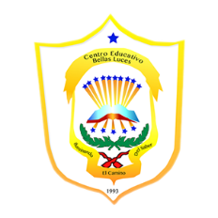República de Panamá

Ministerio de Educación

Educación Particular

Centro Educativo Bilingüe Bellas Luces

Date: **Monday April 13 to Friday 17.**  Teacher: Yinelli Núñez

**SUBJECT: SCIENCE TEST** LEVEL: 8 GRADE

***“AS FOR ME AND MY HOUSE WE WILL SERVE THE LOARD” JOSHUA 24:15***

OBJECTIVE:

1. Understand the main topic about the last week with a technological quiz in an education system.

**Instructions: Read and review the topic of the biodiversity and answer this questions.**

1. **What is biodiversity?**
2. **How many species of plants have estimated Scientist?**
3. **Mention the country that have more biodiversity than others.**
4. **How is called the areas with extremely high levels of biodiversity.**
5. **Mention some example of biodiversity of one of the country you have in your chart.**

Study this topic and remember you must be prepare for oral questions.