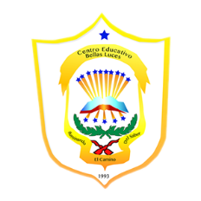República de Panamá

Ministerio de Educación

Educación Particular

Centro Educativo Bilingüe Bellas Luces

Date: **Monday April 13 to Friday 17.**  Teacher: Yinelli Núñez

**SUBJECT: SCIENCE TEST** LEVEL: 6 GRADE

***“AS FOR ME AND MY HOUSE WE WILL SERVE THE LOARD” JOSHUA 24:15***

OBJECTIVE:

1. Understand the main topic about the last week with a technological quiz in an education system.

Instructions: Study the last vocabulary with the spell and be prepare for oral presentation on Friday.

Present your science experiment: Give your presentation (name, level and subject), and be prepare for answer the name of your product and the materials you use.