República de Panamá

Ministerio de Educación

Educación Particular

Centro Educativo Bilingüe Bellas Luces

Date: **Monday 30 March to Friday 03** Teacher: Yinelli Núñez

**Módulo Mensual**

**SUBJECT: GRAMMAR** LEVEL: 6 GRADE

***“THE LORD IS WITH ME, I WILL NOT BE AFRAID, THE LORD IS WITH ME, HE IS MY HELPER” PSALM 118:6-7***

OBJECTIVE:

1. Develop the importance to use the correctly grammar structure in a sentence.

TOPIC: LIKE – ING

EXPLANATION:

LIKE IS A VERB (GUSTAR). When there is another verb after like, we use the ING form. For example: 1. I like playing soccer. 2. She likes playing soccer.

**RULER: AFFIRMATIVE**   **NEGATIVE**

**I/ YOU/WE/THEY = DONT LIKE**

**HE /SHE= DOESN’T LIKE**

**I /YOU/THEY WE = LIKE – ING**

**HE / SHE = LIKES - ING**

**QUESTIONS**  **SHORT ANSWER**

**I /YOU/THEY/WE= YES,DO / NO, DONT**

**HE/SHE = YES,DOES / NO, DOESN’T**

**I/YOU/THEY/WE = DO YOU**

**HE/SHE = DOES HE OR SHE**

¨

ACTIVITY: READ THE EXPLANATION, SEE THE VIDEO AND WRITE IF THE SENTENCES ARE (AFFIRMATIVE, NEGATIVE, QUESTIONS AND ANSWERS.),CIRCLE THE SINGULAR PRONOUN WITH COLOR AND PLURAL PRONOUN WITH OTHER COLOR.

1. I LIKE GOING TO THE PARK.
2. SHE DOESN’T LIKES THE TV.
3. DO YOU EATING THIS MORNING?
4. YES, I DO.
5. NO, I DON’T
6. HE LIKES PLAYING SOCCER.
7. WE DON’T JUMPING IN THE PARK.
8. DOES HE GOING TO THE CINEMA?
9. I LIKE SINGING IN HOME.
10. SHE DOESN’T LIKE THE HAMBURGER
11. DO THEY LEARNING THE LESSON?

**TRADUCCION: LEER LA EXPLICACION, VER EL VIDEO, IDENTIFICAR SI LA ORACION ES AFIRMATIVA, PREGUNT, NEGATIVA, RESPUESTA CORTA. Y CIRCULAR LOS PRONOMBRES SINGURALES CON UN COLOR Y LOS PLURALES CON OTRO COLOR.**

República de Panamá

Ministerio de Educación

Educación Particular

Centro Educativo Bilingüe Bellas Luces

Date: **Monday 30 March to Friday 03** Teacher: Yinelli Núñez

**Módulo Mensual**

**SUBJECT: READING** LEVEL: 6 GRADE

***“THE LORD IS WITH ME, I WILL NOT BE AFRAID, THE LORD IS WITH ME, HE IS MY HELPER” PSALM 118:6-7***

OBJECTIVE:

1. Use the headings to find specific information.

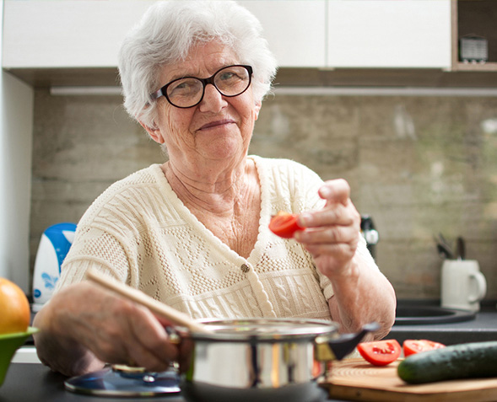

TOPIC: SHORT STORY- GRANDMOTHER CHEF

Do you love your grandmothers' cooking?  Then go to restaurant *Enoteca Maria*, in New York. At Enoteca Maria, grandmothers are the chefs!  
  
Jody Scaravella owns Enoteca Maria. Scaravella is Italian, but he grew up in New York. His grandmother taught him about Italian culture. She cooked Italian foods. When Scaravella's grandmother and mother died, Scaravella opened Enoteca Maria. He wanted to be around grandmothers. It made him feel better.  
  
Every day there are two grandmothers, or *nonnas*, in the restaurant's kitchen. (*Nonna* means "grandmother" in Italian.) One nonna is from Italy; she cooks Italian food. The other nonna is from a different country. For example, Nonna Zena is from Syria. She makes *mutabbal*, (eggplant dip). Nonna Rosa Maria is from Colombia. She makes *tortas de zanahoria*, (carrot cake). The nonnas decide what foods to make. They use recipes they got from their mothers and grandmothers.  
  
Nonnas also talk with customers. "I feel like I'm cooking for my family," says Nonna Rosa, from Veneto, Italy. "And that's what the customers become - my family."

ACTIVITIES: READ THE STORY AND UNDERSTAND THEM. AFTER READ THE QUESTIONS AND ANSWER IN COMPLETE PHRASE.

QUESTIONARY #1

1. What is the name of the restaurant and where is located?
2. What are the chef of the restaurant?
3. What is the nationalities of Jody Scaravella?
4. Which type of food cooked?
5. When Mr. Scaravella opened the restaurant?
6. What is the meaning of the word nonna?
7. Mention some dishes do the nonnas in the restaurant.
8. Do a drawing about something for the story.

República de Panamá

Ministerio de Educación

Educación Particular

Centro Educativo Bilingüe Bellas Luces

Date: **Monday 30 March to Friday 03** Teacher: Yinelli Núñez

**Módulo Mensual**

**SUBJECT: SPELLING** LEVEL: 6 GRADE

***“THE LORD IS WITH ME, I WILL NOT BE AFRAID, THE LORD IS WITH ME, HE IS MY HELPER” PSALM 118:6-7***

OBJECTIVE:

1. Recycle vocabulary about some activities you can do in home.

Topic: VOCABULARY- ACTIVITIES AND VERB.

Instructions: Re-order the words in the alphabet form and write the meaning in Spanish.

1. Try to practice the spelling be for each word.

Vocabulary

Play, swim, eat, sit, watch, go, sing, dance, read, listen, talk, see, jump, run, and learn.

[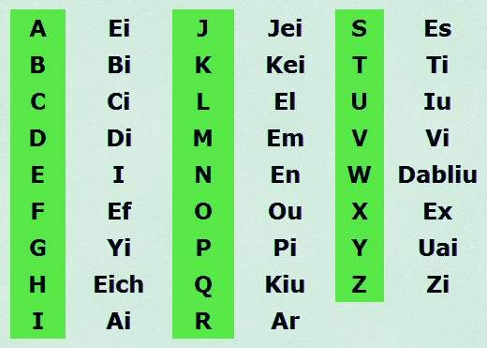](https://www.google.com/url?sa=i&url=https%3A%2F%2Fwww.pinterest.com%2Fpin%2F14707136269109873%2F&psig=AOvVaw0UTtSgNIh6ut4I9Lt8ukx4&ust=1585846094095000&source=images&cd=vfe&ved=0CAIQjRxqFwoTCLipo6HXx-gCFQAAAAAdAAAAABAD)